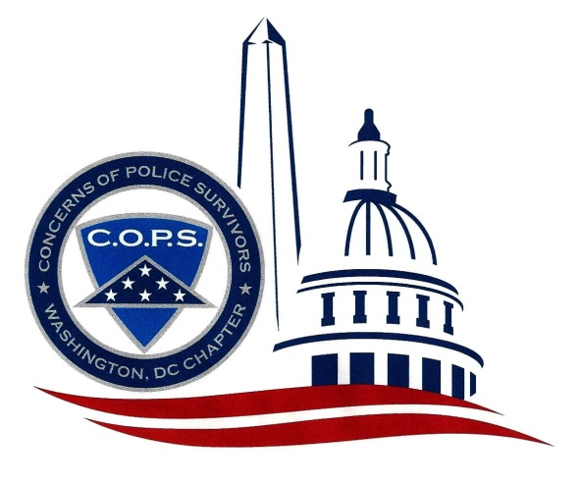
WASHINGTON, DC Chapter of
Concerns of Police Survivors
P.O. Box 31549
Washington, DC 20030-1549
202-332-2677 www.dc-cops.org

Please provide the below information for listing in our DC Chapter and C.O.P.S. National Office. Please print all information.

Full Name:

Mailing Address (street/city/state):

Phone Number(s) -- indicate home and/or cell:

Email address you want used:

Your Spouse's Name, if applicable:

Name of your fallen officer(s):

Fallen Officer's End of Watch (EOW) date:

Fallen Officer's Agency/Department at the time of death:

Your relationship to the fallen officer:

Other survivor(s) you wish to have added to the listing (provide the same information for each of them) -- use additional sheet of paper if necessary:

